KFCCALMT9709 - EXAM PAPER - 200408 - MATHS P1 - TRIAL EXAM - TAYLOR

- (i) 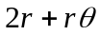 (ii) 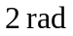
- 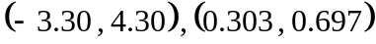
- 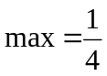 , 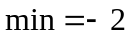
- 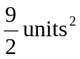
- (i) 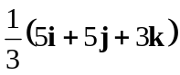 (ii) 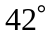
- (i) 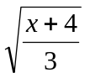 (ii) 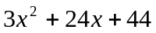
- 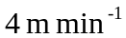
- (b) 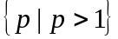
- (a) 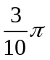 (c) 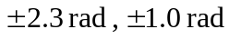
- (a) 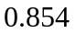 (b) 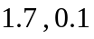 ; 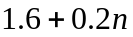
- (a) 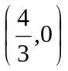 (b) 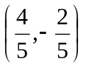 (c) 